**Four treatments on Tumor test comparison**

**(Capomulin, Infubinol, Ketapril, and Placebo)**

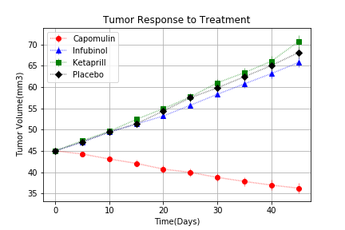

Conclusion 1: Capomulin has the best tumor response in all four treatments, tumor volumes size went down during treatment time while the other 3 treatments cannot reduce the tumor size.

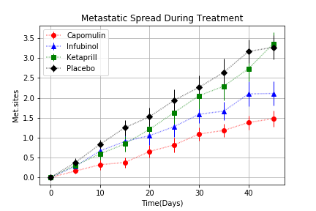

Conclusion 2: Capomulin also have the lowest number of the metastatic site during treatment time, which may help to lower the chance of tumor spreading.

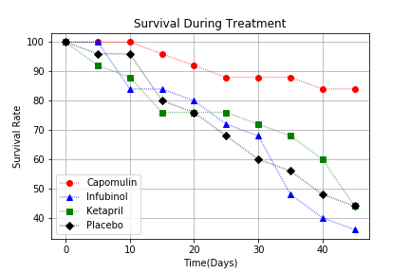

Conclusion3: Capomulin has 84% of the animal survive rate which is also the best preferment treatment in all.

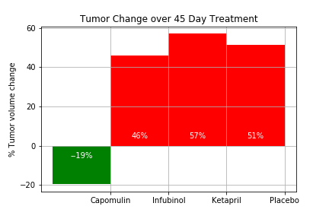

Summary: Capomulin is the best candidate in all the treatment, it can reduce size of the tumor and has the lowest metastatic site number and the animal survive rate is the highest